Nitric Acid (HNO₃)
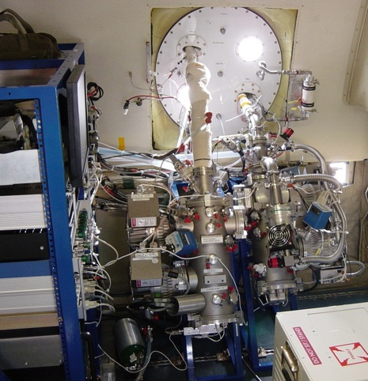

Principal Investigator:
Andy Neuman:
NOAA ESRL Chemical Sciences Division
jonathan.a.neuman@noaa.gov

Principle of the Measurement
Chemical Ionization Mass Spectrometry (CIMS) using SiF5- ion chemistry

Species Measured
Nitric Acid

Time Response
1 Second

Detection Limit
Precision on 1s data: 20 pptv (1 sigma) depending on field project

Accuracy
±(15% + 100 pptv) depending on field project

Manufacturer
custom built

Field Projects
SOS 1999
TexAQS 2000
ITCT 2002
ICARTT 2004
Mesa 2005
TexAQS 2006
2008 ARCPAC (used to measure halogens)
CalNex 2010

Key Publications
Neuman, J. A., L. G. Huey, R. W. Dissly, F. C. Fehsenfeld, F. Flocke, J. C. Holecek, J. S. Holloway, G. Hübler, R. Jakoubek, D. K. Nicks Jr., D. D. Parrish, T.B. Ryerson, D. T. Sueper, and A. J. Weinheimer, Fast-response airborne in situ measurements of HNO3 during the Texas 2000 Air Quality Study, J. Geophys. Res., 107(D20), 4436, doi:10.1029/2001JD001437, 2002.

Neuman, J. A., T. B. Ryerson, L. G. Huey, R. Jakoubek, J. B. Nowak, C. Simons, and F. C. Fehsenfeld, Calibration and evaluation of nitric acid and ammonia permeation tubes by UV optical absorption, Environ. Sci. Technol., 37, 1975-2981, doi:10.1021/ES06422L, 2003.

