In situ Airborne Formaldehyde (ISAF) for SENEX 2013
Co-PI Frank N. Keutsch
University of Wisconsin, Madison
keutsch@chem.wisc.edu

Co-PI Thomas F. Hanisco
NASA Goddard Space Flight Center, Code 614
thomas.hanisco@nasa.gov

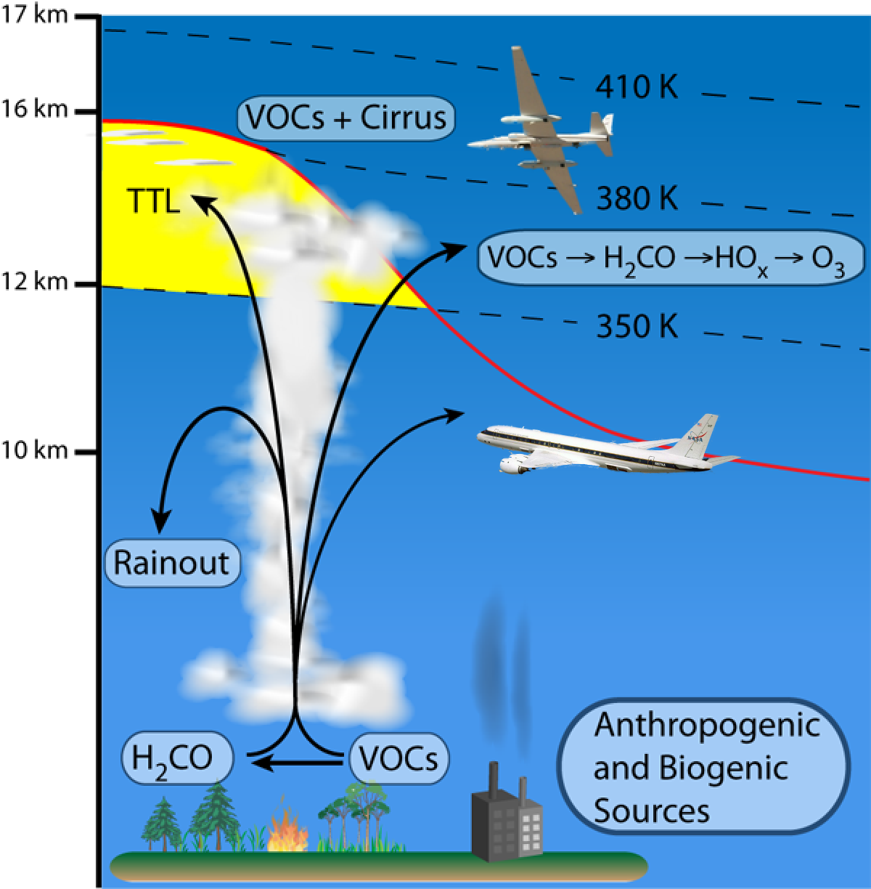
The NASA GSFC In Situ Airborne Formaldehyde (ISAF) Instrument measures formaldehyde on high altitude NASA aircraft. The instrument uses laser induced fluorescence (LIF) to obtain the high detection sensitivity needed to detect formaldehyde in the upper troposphere and lower stratosphere where abundances are 10 parts per trillion. LIF also enables a fast time response needed to measure the abundance of formaldehyde in the finely structured outflow of convective storms. These measurements of formaldehyde will be used elucidate mechanisms of convective transport and quantify the effects of boundary layer pollutants on the ozone photochemistry and cloud microphysics of the upper atmosphere.
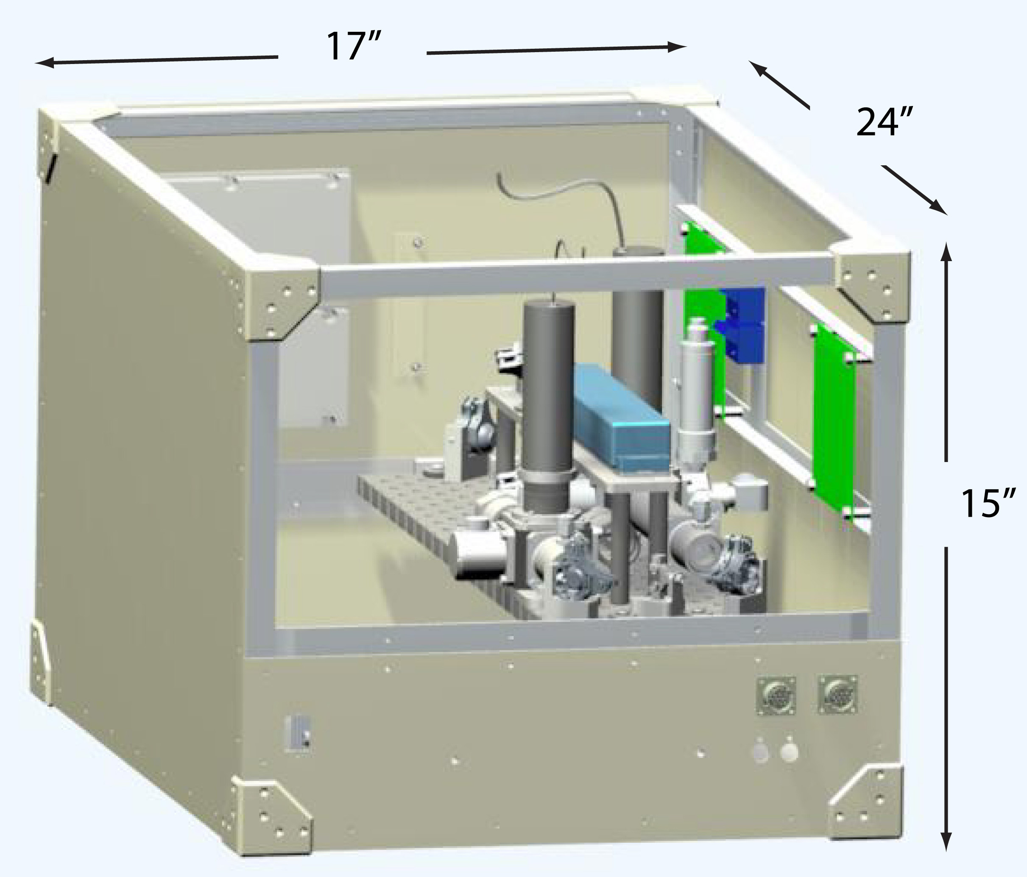
The ISAF instrument is designed for autonomous operation on high altitude aircraft where small size and weight is desirable. The core instrument, shown on the left, weighs 25 kg and draws 200W of power. For lower altitude operation on the DC-8 and P-3 a small pump (10 kg) is needed to reduce the pressure in the detection cell below 500 mbar. In addition, a user interface box (10 kg) is included to replicate the cockpit switches in the WB57 and ER2 and to operate the pump. A particle-rejecting inlet is used on all platforms to draw sampled air into the instrument.
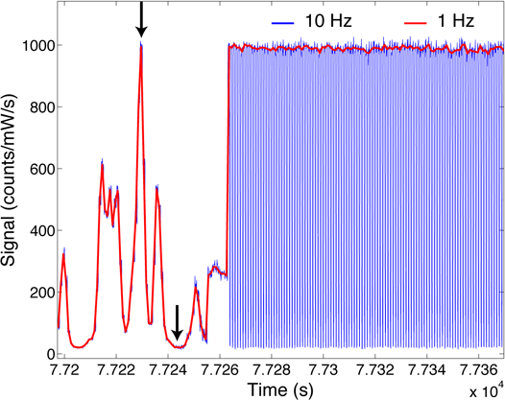
The ISAF instrument uses a pulsed tunable fiber laser to detect the formaldehyde in the sampled air with LIF. The laser is used to excite a single rotational transition of the A − X band at 353.16 nm and the resulting fluorescence is detected with a photon counting photo multiplier tube. The laser is pulsed to aid in removing the background and the laser wavelength is tuned to ensure specificity in the detection of formaldehyde. By tuning the laser on and off resonance with single rotational feature of formaldehyde, contributions of potentially interfering species can be removed. The example on the right shows the laser wavelength tuned through several rotational features, with the online and off-line positions marked by arrows, followed by the alternating measurement of the signal at the online (for 700 ms) and offline (for 300 ms) positions. The difference is used to determine the abundance of formaldehyde in the sampled air. Since the wavelength difference between the online and offline positions is only 0.005 nm, the contribution from non-resonant processes is removed.
The sensitivity of the LIF technique is dependent on laser power and the pressure in the detection cell. With a laser power of 20 mW and a pressure of 200 mbar in the detection cell, the 1-σ precision is ~10 ppt in 1 s integration. The time response of the measurement is limited by the flush time of the detection (25 cm³) and sampling (50 cm³) volumes and by the reversible uptake of formaldehyde on surfaces. Fast flows (500 cm³/s) give a primary flushing time constant of 0.15 s and specialized coatings in the heated sampling lines give a secondary uptake time constant of less than 0.25 s. The instrument is calibrated with standard addition of formaldehyde gas mixtures. The 1-σ uncertainty of the measurement is ±10%.

In Situ Airborne Formaldehyde Instrument Characteristics.
The P-3 configuration includes the pump and control interface.
Volume | 16 U (28” of vertical height on a 19” rack)
Weight | 50 kg
Power | 600 W
Precision | 10 pptv/s
Accuracy | 10%
Data rate | 1 s (100 ms on request)

