Carbon Dioxide (CO₂) and Methane (CH₄)

Principal investigators:
Jeff Peischl
University of Colorado Boulder, CIRES
jeff.peischl@noaa.gov
Tom Ryerson
NOAA ESRL Chemical Sciences Division
thomas.b.ryerson@noaa.gov
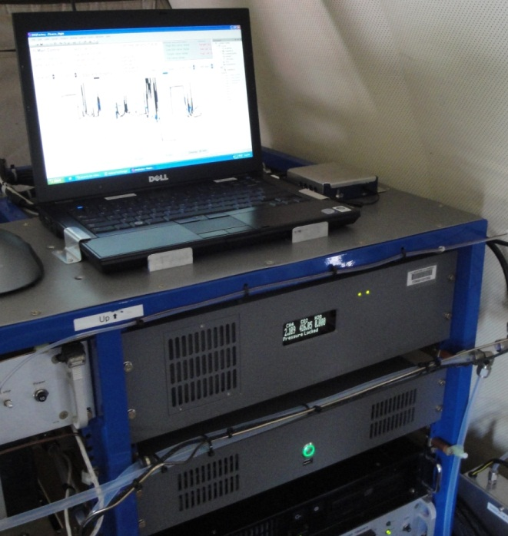

Measurements of the greenhouse gases carbon dioxide (CO₂) and methane (CH₄) will be used to determine the sources and magnitudes of these emissions in the southeast U.S. during SENEX. CO₂ and CH₄ are measured aboard the NOAA P-3 aircraft using a modified commercial wavelength-scanned cavity ring-down analyzer (Picarro 1301-m). Atmospheric air is sampled through a 3/8 in. OD stainless steel rearward facing inlet on the NOAA P-3 and dried to a dew point temperature of –78°C after passage through a 200-strand Nafion dryer and a dry ice trap. The absorption cell pressure is controlled at 140 Torr (±0.2 Torr during smooth flight, and ±0.5 Torr during typical boundary layer flight conditions; all stated uncertainties are ±1σ).
Immediately inside the fuselage, two CO₂ and CH₄ calibration gas standards are regularly delivered to the inlet line during flight to evaluate instrument sensitivity. The calibration standards bracket the expected ambient range of each gas and are known to within ±0.07 ppm CO₂ and ±1 ppb CH₄ (all CO₂ and CH₄ mixing ratios are reported as dry air mole fractions). The calibration gases are added at a flow rate sufficient to overflow the inlet. These flight standard tanks, or secondary standards, are calibrated before and after the field project using primary CO₂/CH₄ standard tanks tied to the WMO standard scale from the Global Monitoring Division (GMD) at the NOAA Earth System Research Laboratory (ESRL). A third calibration standard (referred to as a “target”) is regularly introduced to the inlet between calibrations and treated as an unknown to evaluate long-term instrument performance.
Independent of the target retrievals, we estimate a total inaccuracy in the CO₂ measurement of ±0.10 ppmv and a total inaccuracy in the CH₄ measurement of ±1.2 ppbv for 20-second averages. One-second imprecision of the CO₂ measurement is ±0.10 ppmv during smooth flight and ±0.15 ppmv during turbulent flight. One-second imprecision of the CH₄ measurement is ±1.5 ppbv during smooth flight and ±2.0 ppbv during turbulent flight.
Reference
Peischl, J., T. B. Ryerson, J. S. Holloway, M. Trainer, A. E. Andrews, E. L. Atlas, D. R. Blake, B. C. Daube, E. J. Dlugokencky, M. L. Fischer, A. H. Goldstein, A. Guha, T. Karl, J. Kofler, E. Kosciuch, P. K. Misztal, A. E. Perring, I. B. Pollack, G. W. Santoni, J. P. Schwarz, J. R. Spackman, S. C. Wofsy, and D. D. Parrish (2012), Airborne observations of methane emissions from rice cultivation in the Sacramento Valley of California, J. Geophys. Res., 117, D00V25, doi:10.1029/2012JD017994.

