Supplementary Material (SM) for “Moisture Pathways into the US Intermountain West Associated with Heavy Winter Precipitation Events”

By Alexander et al.

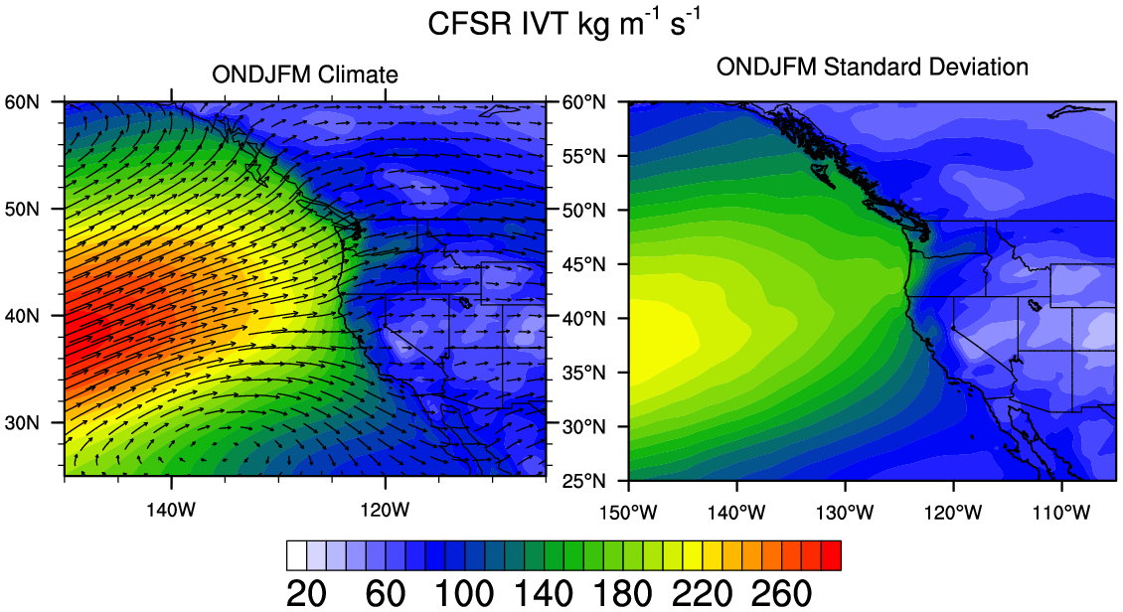

Fig. SM1. The (left) climatological mean and (right) standard deviation of the integrated Water Vapor Transport (IVT, kg m⁻¹ s⁻¹) computed using 6-hourly values during October-March from 1979-2011 in CFSR. Shading shows the magnitude (scale at bottom) equal length vectors show the direction of the mean IVT.

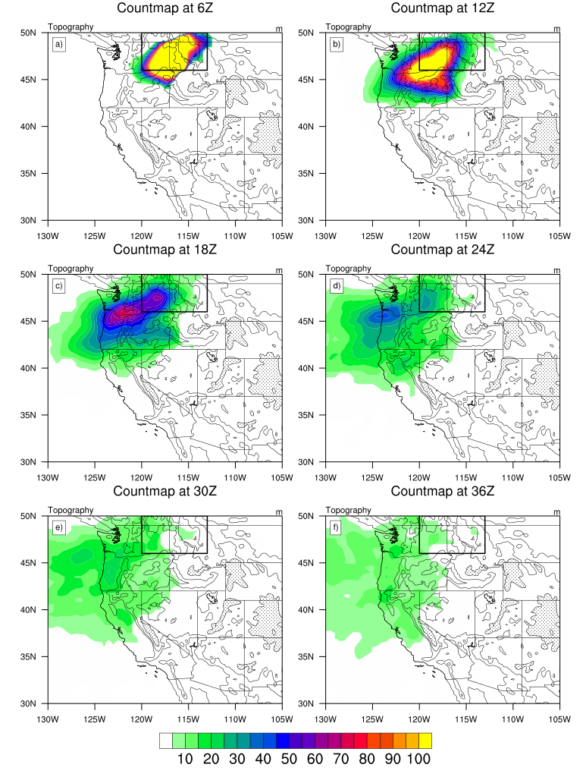
Fig. SM2 Back trajectory count maps at 6-hour intervals (e.g. 0-6 hrs, 6-12 hrs, 12-18 hrs, … 30-36 hrs) prior to the heavy precipitation event in the WA-nID region.

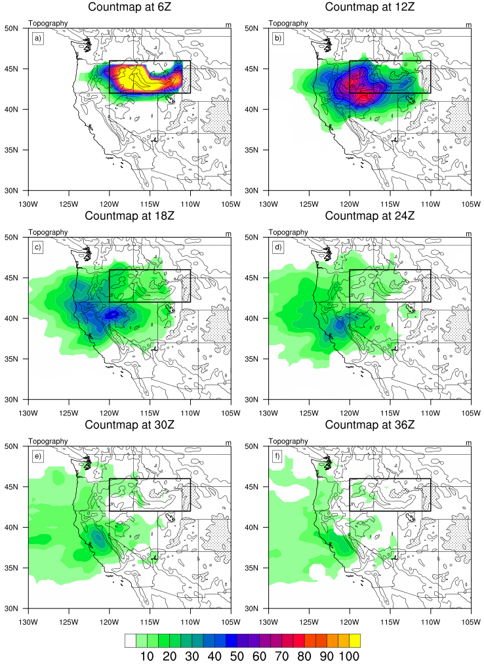
Fig. SM3 Back trajectory count maps at 6-hour intervals for the OR-sID region. The local maximum over the central CA valley at 24-36 hours indicates that air parcels may slow or meander in this region with their progress blocked by the high Sierras.

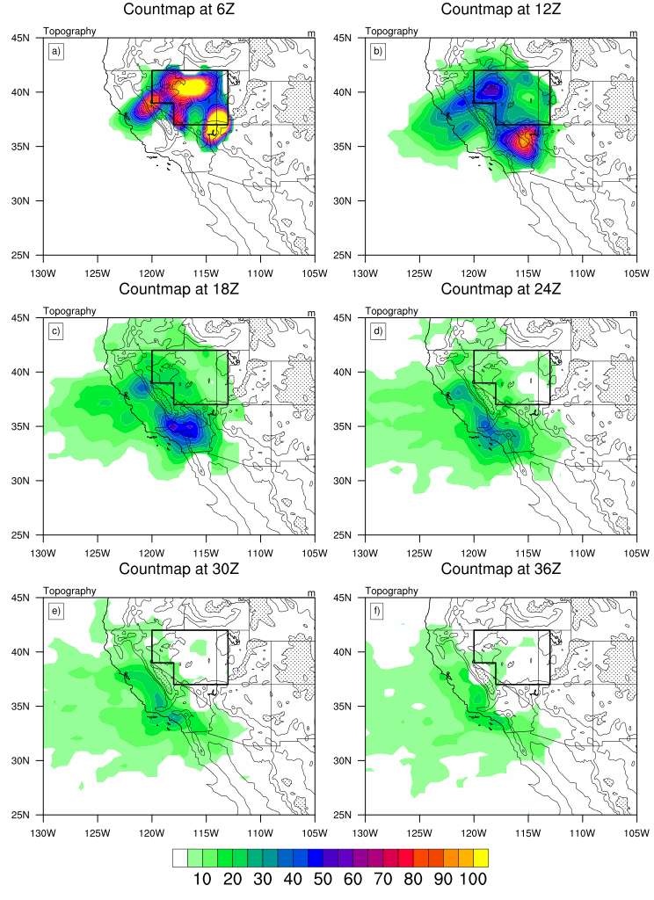

Fig. SM4. Back trajectory count maps at 6-hour intervals for the NV region.

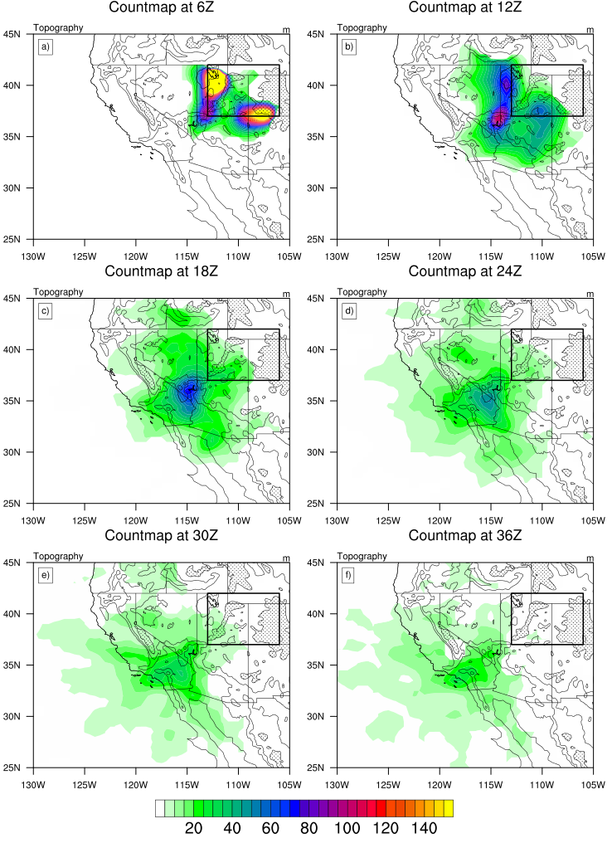

Fig. SM5. Back trajectory count maps at 6-hour intervals for the UT-CO region.
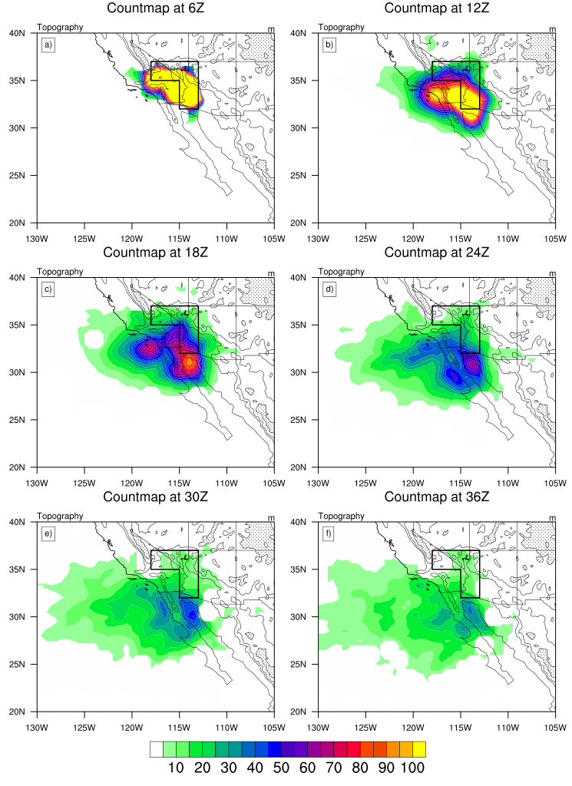

Fig. SM6. Back trajectory count maps at 6-hour intervals for the sCA region.

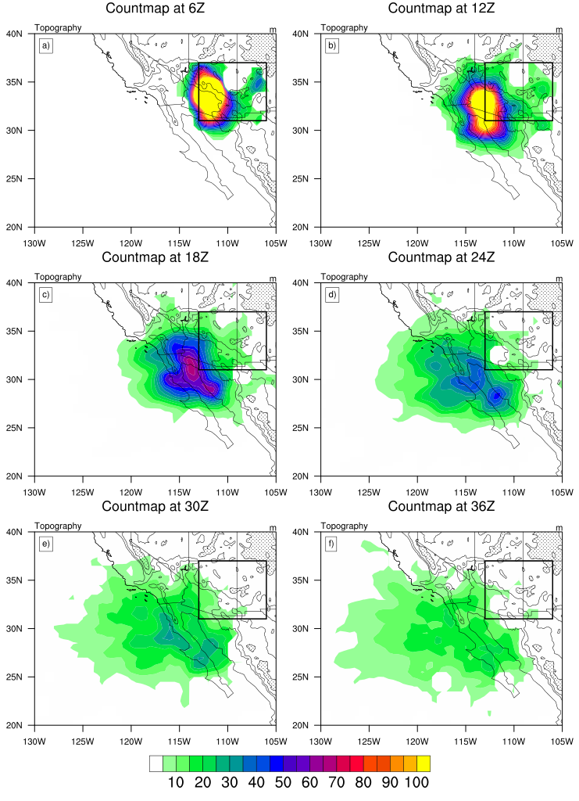

Fig. SM7. Back trajectory count maps at 6-hour intervals for the AZ-NM region.

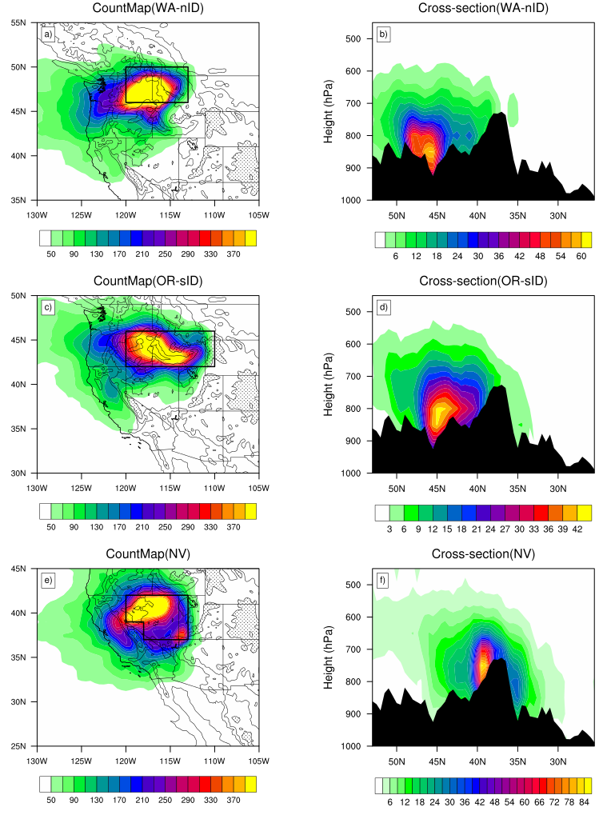

Fig. SM8. Count maps and cross sections for back trajectories, as in Fig. 4 but here generated on random dates.
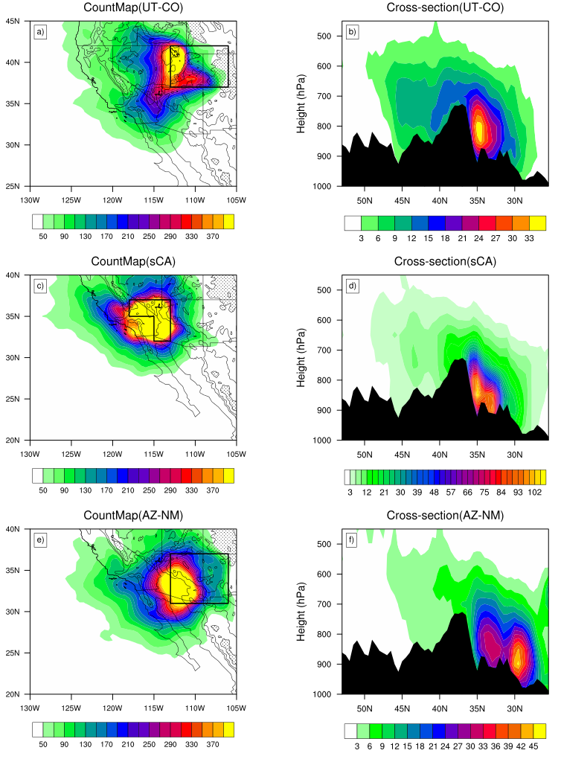

Fig. SM9. Count maps and cross sections for back trajectories, as in Fig. 4 but here generated on random dates.

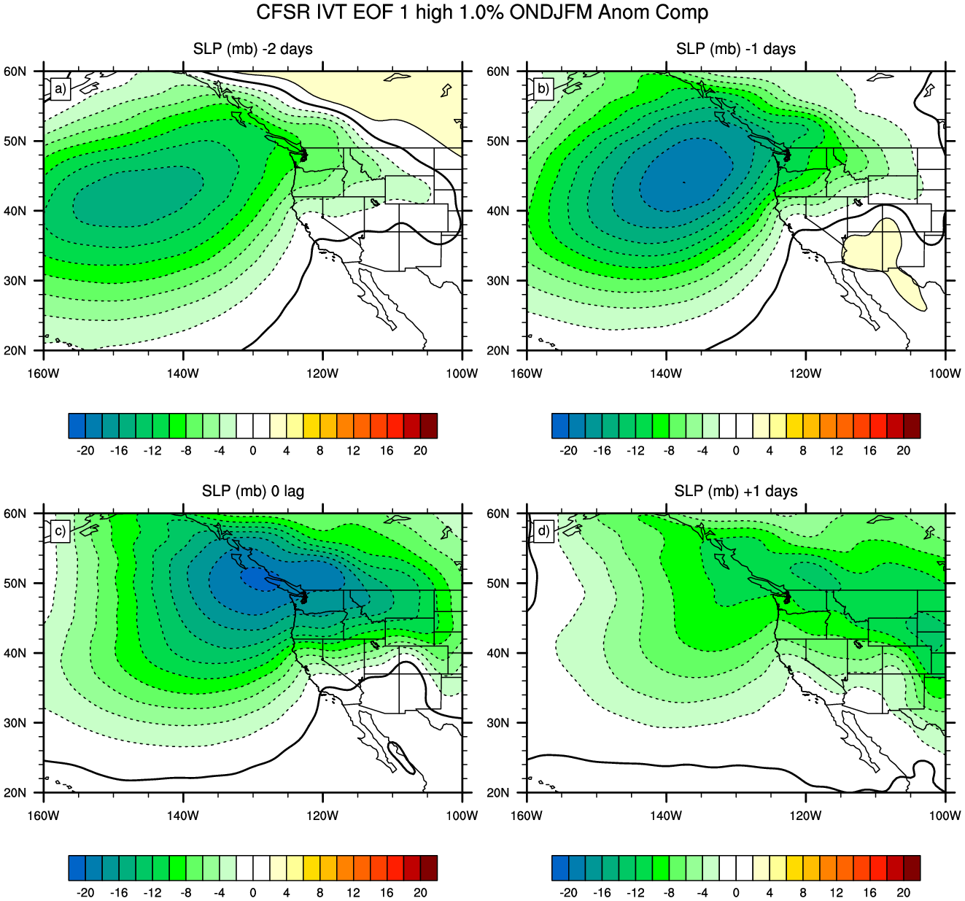

Fig. SM10. As in Fig. 9, high composite maps constructed from the days during which the top 1% of PC1 values of IVT occur, but here for SLP anomalies at lags of a) -2 days B) -1 day c) zero and + 1 day. Zero lag corresponds to the same times as used in the composites shown in Fig. 9. Upon reaching the west coast of North America the northern end of the low extends eastward more rapidly then the remainder of low and the entire circulation becomes zonally elongated by lags 0 and +1 days. This results in a strong gradient with eastward flow at low levels conducive to onshore flow and the penetration of air through the mountain gaps that mainly have a north-south orientation

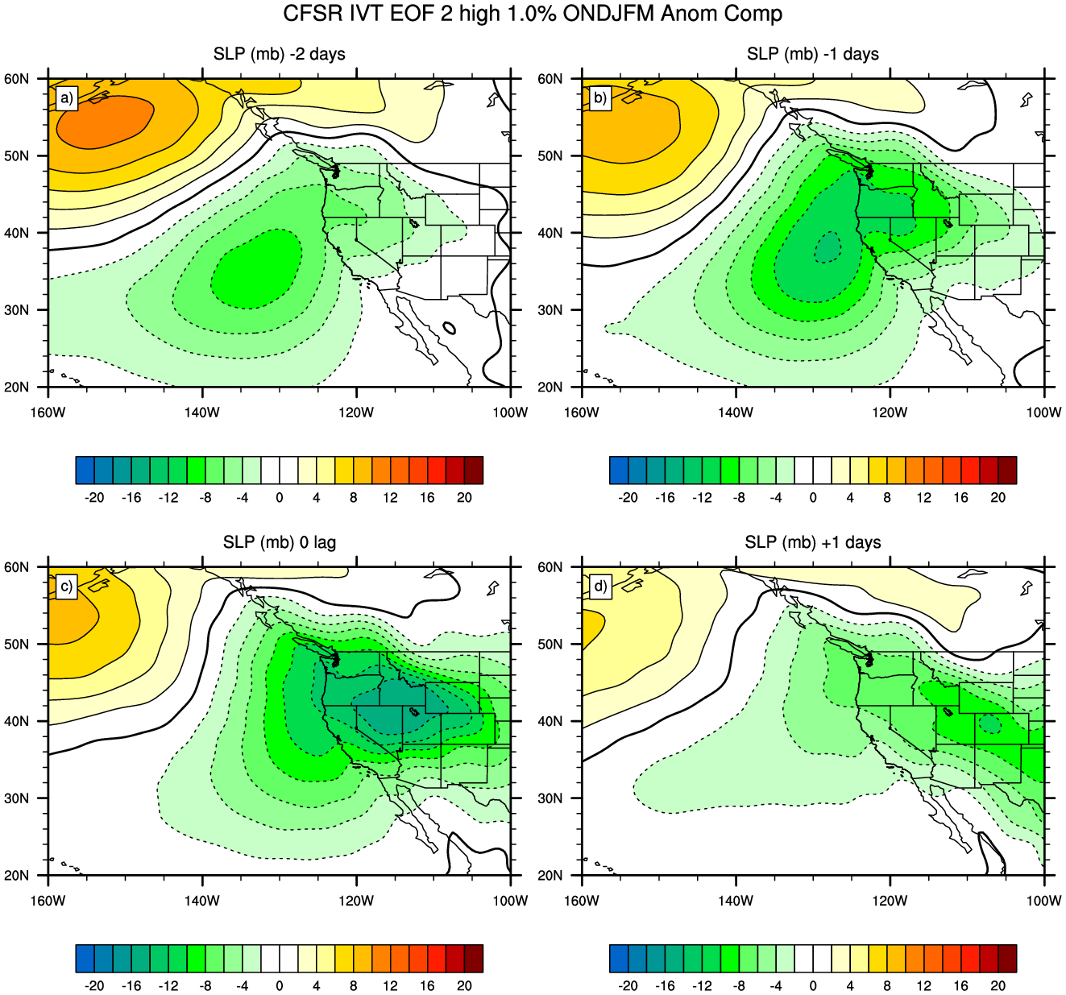

Fig. SM11. As in Fig. 10 but for the high PC2 based composites for SLP at lags from -2 days to +1 days.

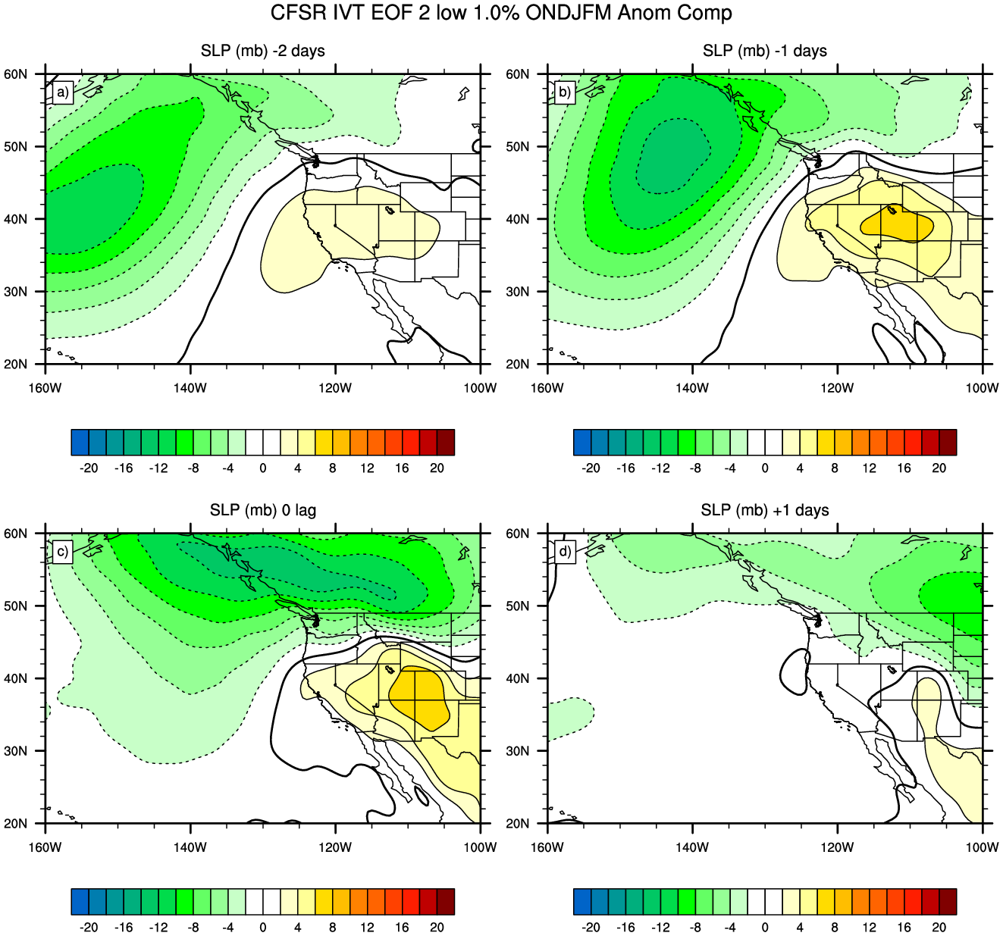

Fig. SM12. As in Fig. 11 but for the low PC2 based composites for SLP at lags from -2 days to +1 days.

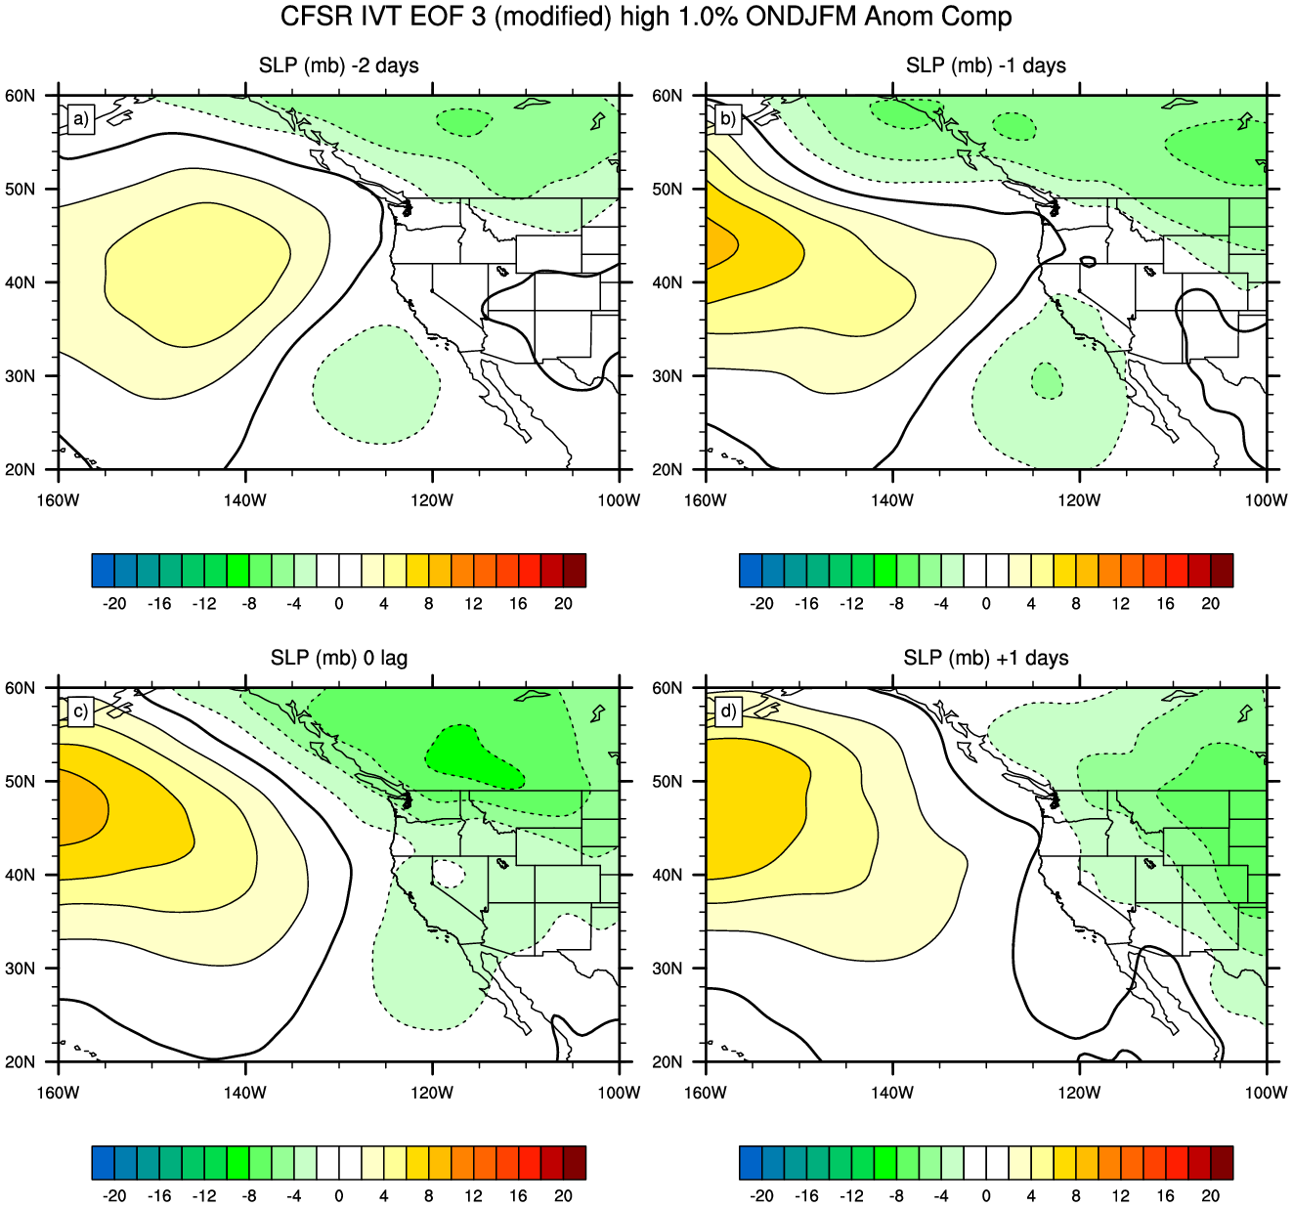

Fig. SM13. As in Fig. 12 but for (modified) high PC3 based composites for SLP at lags from -2 days to +1 days. The PC3 based composite exhibits a modest cutoff low at surface in the eastern Pacific that propagates onshore by lag 0 and merges with a northern trough from lag 0 to +1

