In-Situ Measurements of Aerosol Particle Size Distributions for SENEX

Charles Brock
NOAA Earth System Research Laboratory, Boulder, CO

The NOAA ESRL cloud and aerosol processes group will operate three instruments that together provide the concentration of particles as a function of their dry size from 0.004 to 7.0 µm diameter. The size distribution is a fundamental property of the atmospheric aerosol, and it contributes to understanding aerosol sources and sinks, optical properties, cloud nucleation potential, and chemical transformations.

Particles with diameters from ~0.004 to 0.07 μm will be measured with a 5-channel condensation particle counter (CPC), the nucleation-mode aerosol size spectrometer (NMASS, Brock et al., 2000). This unique instrument samples particles into a low pressure (~100 hPa) region where they are exposed to a warm vapor from a perfluorinated organic compound. The sample airstream is then cooled, producing a supersaturation of the vapor. Particles larger than a critical size are nucleated, form a droplet of the organic fluid, and are counted with a simple laser optical counter. Each of the five NMASS channels operates at a different temperature, so that the critical diameter varies in each. Particles with diameters larger than 0.004, 0.008, 0.015, 0.030, and 0.055 µm are nucleated and counted independently. Differencing the channels provides a coarse resolution--but fast (1 second) time response--measurement of the size distribution of ultrafine particles.

Particles with diameters from 0.07 to ~1.0 μm will be measured by an ultra-high sensitivity aerosol spectrometer (UHSAS, Brock et al., 2011). The aerosol sample enters a resonant cavity that is driven by a solid-state laser at 1053 nm wavelength. The size of each particle is determined by measuring the amount of side-scattered light reaching two solid-state photodiode detectors. The instrument is housed in the same rack as the aerosol optical properties (AOP) instruments, and samples from the same dried (<10% relative humidity, RH) airstream that supplies the optical instruments. The UHSAS has been substantially modified from the commercial laboratory version (Droplet Measurement Technologies, Boulder, Colorado) and has been equipped with an RH control system. The RH of the sample can be switched between the default dry mode and an elevated humidity (~85% RH). The change in the aerosol size distribution can be used to evaluate the hygroscopicity of the particles. The humidified and dry size distribution can be used to calculate how aerosol properties, such as directional scattering (asymmetry parameter) vary with atmospheric humidity.

Particles with diameters from ~0.7 to 7.0 μm will be measured with a custom-built white-light optical particle counter (WLOPC). This instrument detects light from a 3-watt white-light-emitting diode (LED) source that is scattered over a wide angle by single particles. The white light source is used to reduce particle sizing biases caused by widely varying particle compositions and shapes that are typical of supermicron aerosol particles. The high sample flow rate of the WLOPC results in acceptable counting statistics for supermicron particles over time periods of ~10 s at typical coarse particle concentrations. The inlet of the WLOPC is maintained at <40% RH by heating the sample line as necessary.

The UHSAS and WLOPC operate in the WP-3D cabin and sample air downstream of the low-turbulence inlet (LTI, Wilson et al. 2004). The LTI actively removes turbulent flow developing along the walls of a conical diffuser. Since the NMASS measures ultrafine particles subject to diffusive rather than inertial losses, it samples instead from a double diffusing inlet in a non-pressurized wing pod.

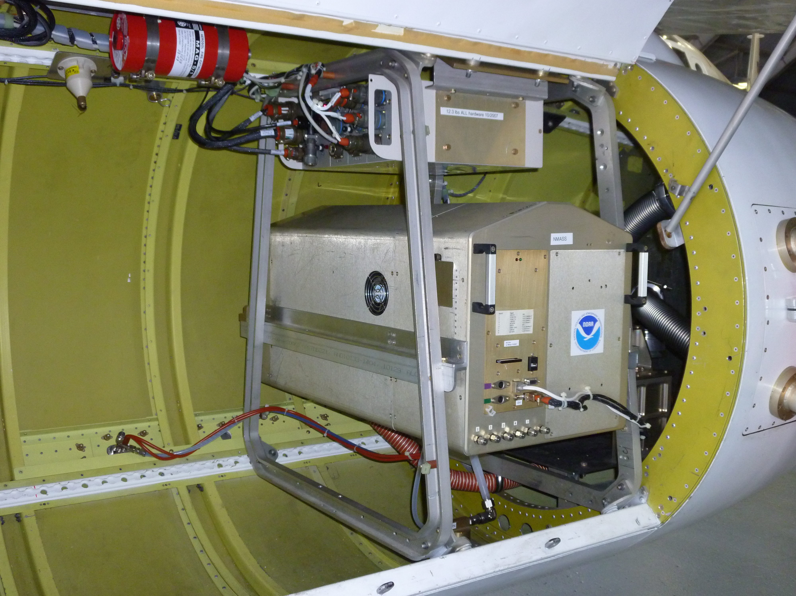

NMASS instrument in underwing pod of NOAA WP-3D aircraft.

References
Brock, C. A., et al.: Ultrafine particle size distributions measured in aircraft exhaust plumes, J. Geophys. Res., 105, 26,555–26,567, 2000.

Brock, C. A., et al., Characteristics, sources, and transport of aerosols measured in spring 2008 during the aerosol, radiation, and cloud processes affecting Arctic Climate (ARCPAC) Project, Atmos. Chem. Phys., 11, 2423-2453, doi:10.5194/acp-11-2423-2011, 2011.

Wilson, J. C., Lafleur, B. G., Hilbert, H., Seebaugh, W. R., Fox, J., Gesler, D. W., Brock, C. A., Huebert, B. J., and Mullen, J.: Function and performance of a low turbulence inlet for sampling super-micron particles from aircraft platforms, Aerosol Sci. Technol., 38, 790-802, 2004.

