I. General information:

1. Mission name: SONGNEX 2015

2. Instrument name: H3O+ CIMS

3. What is measured:
Volatile organic compounds (VOCs): e.g. methanol, acetonitrile, acetaldehyde, acetone, acetic acid, isoprene, methyl ethyl ketone, benzene, toluene, xylenes, trimethyl benzenes, sum monoterpenes

4. Short description of measurement technique:
Measures VOCs by H3O+ chemical ionization and mass spectrometric detection of the product ions.

5. Contact information for all personnel going to the field with this instrument:
(for multiple investigators, please list the PI or primary contact person first)

Name | Email | Office phone | Cell phone
Bin Yuan, PI | Bin.Yuan@noaa.gov | 303-497-5568 | 720-530-8421
Abigail Koss | Abigail.Koss@noaa.gov | 303-497-3819 | 970-689-2592

II. Specific information:

1. Total installed weight: 248 lbs
(rack, gas cylinders, hoses, cabling, pumps, inlets, permeation tubes, etc.)

Rack weight and balance info | Allowed | Actual
Weight, lbs.: | 375 | 355
Overturning moment, in-lbs.: |  | 5640

Pod weight and CG:

NOTE: Please also provide weight-and-balance information for all installed equipment. Templates for standard electronics racks are available for download here. PIs with non-standard installations will need to provide relevant information in a similar format.

2. Individual subassembly info (weights should sum to total listed above)

Component name | Location name and flight station | Weight, lbs
1 H3O+ CIMS rack | Sta8, FS 892 | 355
2 H3O+ CIMS winglet + window plate** | Sta8 camera port, FS910 | 10

3. Component power consumption in Amps;

Electrical power diagram in Appendix A

Component name | Location name | 400 Hz  3Ø | 400 Hz  1Ø | 60 Hz | 28VDC | 28VDC  WOW
1 H3O+ CIMS | Sta8 |  | 6A (running)
 |  |  | 7A (startup)
 | Totals: | 0 | 6
 |  | 400 Hz  3Ø | 400 Hz  1Ø | 60 Hz | 28VDC | 28VDC  WOW

4. Inlet and exhaust information:

Inlet/exhaust line diagram in Appendix B

Inlet/exhaust name | Location name and flight station | Hole size through hull, inches
- H3O+ CIMS inlet | Sta8 camera port, FS910 | 3.75”
2. H3O+ CIMS exhaust | LIPF venturi plate, FS780 | 0.375”

5. Source of flow (name and location of pump or venturi)

Pump name | Location name and flight station
1. membrane pump | Sta8/Rack, FS892

6. Installed hazardous materials or equipment:
(only for items installed in the aircraft for use during flight)

A. Lasers: N/A

B. RF transmitters: N/A

C. Radioactive materials: N/A

D. Compressed gases: (1 ft³ = 28.32 liters; cabin volume = 4260 ft³ = 1.21 x 10⁵ liters)
N/A

Cylinder number: | 1
Gas description | 1 ppm each of 10 hydrocarbons: methanol; acetonitrile;  acetaldehyde; Acetone; MEK; Isoprene; Benzene; Toluene; xylene;  124 trimethylbenzene
Mixing ratio | 1ppm
Cylinder size (ft³) | 0.36
Max pressure (psig) | 500
# installed on aircraft | 1
Location on aircraft | Sta8/Rack, FS892
Service frequency | Once, on install
toxic/flammable gases:
In containment vessel?
Gas alarm provided?
MR if vented to cabin, ppmv
OSHA 8-hr PEL, ppmv
30-min IDLH, ppmv

E. Chemicals (solids and liquids):

Chemical number: | 1 WATER | 2 1,4-DIIODOBENZENE
Concentration | Pure | Pure
Amount | 0.5L | <1mg
Container description | Stainless container | Permeation tube
Purpose | Ion production | Mass calibration
Solution pH | 7 | N/A
Spill kit provided? | NO | NO

F. Cryogens: N/A

G. UPS and battery installation: N/A

H. Motors/Pumps

Description: Turbo Pump Pfeiffer Splitflow 310
Motor current draw (24V, 6 A startup, ~1.7 A running)
Thermal interlock enabled? Yes

Description: Turbo Pump Pfeiffer TMH 071
Motor current draw (24V, 3A startup, 1A running)
Thermal interlock enabled? Yes

Description: Membrane Pump 1 Pfeiffer MVP020
Motor current draw (24V, 3.5 A startup, ~2 A running)
Thermal interlock enabled? No

Description: Membrane Pump 2 Pfeiffer MVP020
Motor current draw (24V, 3.5 A startup, ~2 A running)
Thermal interlock enabled? No

Description: Membrane Pump 3 Pfeiffer MVP020
Motor current draw (24V, 3.5 A startup, ~2 A running)
Thermal interlock enabled? No

I. Operator seat requests 1
Test flights: 1
Transit flights: 1
Science flights: 1

7. Data and plumbing drops

Network (Cat. 5/6 ethernet) drops requested: yes

Serial drops requested: no

IRIG-B drops (BNC coax connector) requested: no

Vacuum/exhaust/ emergency dump lines:

Name | Flow rate, slpm | Line pressure, Torr | Pump type | Trace gas concentration(s)
1. H3O+ CIMS exhaust | ~0.5 | ambient | Membrane pump | Air with high RH: up to 100%: condensation possible
2.
3.
4.

Ground gas service lines (number, location, type of service): none

Other gas lines (number, location, type of service): none

Will you be sending data to the AOC data station? If so, please provide the following information: no

Parameter name | Voltage range | Unit conversion
1.
2.
3.

8. Aircraft access

a. flight days:
Pre-flight time requested at aircraft (hours): 3h

Routine pre-flight ground support required? none
(stands, ladders, forklifts, covers, external equipment, etc.)

Routine post-flight time requested at aircraft (hours): 1h

Routine post-flight ground support required? no
(stands, ladders, forklifts, covers, external equipment, etc.)

b. non-flight days:
Routine external access to inlets or zenith mounts required? no
(please describe location, how often, for how long, type of ground support equipment needed, weather constraints, etc.)

Please note there is zero access and zero power to the aircraft (including pods) on hard-down days. These occur at least once every seven calendar days while in the field.

9. Aircraft maneuvers

Briefly describe in-flight calibration frequency, duration, altitudes desired:

In-flight calibrations are done 1 minute every 15 minutes, zeros are done for about 1 minute every 15 minutes

Briefly describe instrument sensitivity to flight conditions:
(issues during roll/pitch, ascent/descent, sampling in cloud, icing etc.)

Sampling in clouds/rain might lead to pick-up of water droplets, which renders the instrument inoperable for a few minutes

10. Miscellaneous

1. Hazmat for preflight/postflight calibrations: Please describe fully any additional hazardous materials - compressed gases, solvents, radioactive ion sources – that you anticipate temporarily bringing onto the aircraft for periodic instrument calibration purposes (e.g., n-butanol in a CN counter, ²¹⁰Po in a DMA, a UPS for power, compressed gas cylinders for calibrations, etc.)

Calibrations: Calibration standard compressed gas cylinder: 1 ppm each in N2 of: methanol, acetonitrile, acetaldehyde, acetone, benzene, toluene, 2-butanone, xylene, 124 trimethylbenzene, isoprene (cylinder size 10L);
Mass calibrations: <1 mg solid di-iodobenzene in permeation tube.
Zero air cylinder

2. Fabrication and sheet metal support: Please describe fully any anticipated requests for fabrication or sheet-metal support during installation in Tampa. This list should be kept to an absolute minimum; please recognize that this superb AOC resource is quite limited. To ease the strain on the AOC shop, we will work with each PI to ensure they arrive in Tampa with as much in hand as possible.

none

3. Ferry flight/check flight procedures. On occasion, AOC will perform an aircraft check flight, during which the instruments may be flown without power. Aircraft maintenance needs may also dictate a ferry flight without science crew or SED techs on board. Instruments should be designed with these eventualities in mind. However, if your instrument requires standby power during this kind of flight, this may be provided at the discretion of AOC personnel.

If so, the flight crew will need to be briefed well ahead of time to ensure proper instrument operation. Please provide with this document a bare-minimum checklist of instrument startup and shutdown procedures requested for these flights. N/A

III. Ground laboratory space

1. Tampa space requests: 2 space at Table

Power requirements: Laptop

Special requests:

2. Field space requests:

Work space, ft²: 30

Number of tables/chairs: 1/2

Power requirements: Laptop, small equipment

Storage space, ft²: 30 (~5 large Boxes)

Other requests:

APPENDIX A: Electrical diagram of the H3O+ CIMS instrument

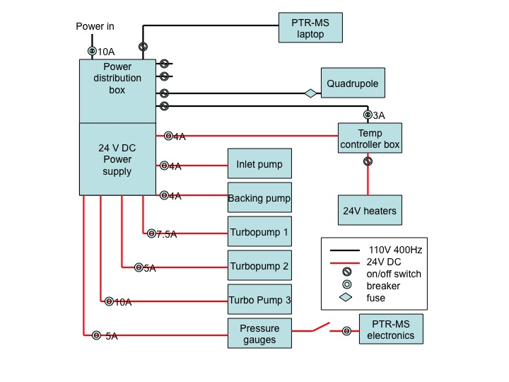

APPENDIX B: Gas flow diagram H3O+ CIMS



