In-Situ Measurements of CCN spectra for SENEX

Athanasios Nenes (PI), Jack Lin and Aikaterini Bougiatioti*
Schools of Earth & Atmospheric Sciences and Chemical & Biomolecular Engineering, Georgia Institute of Technology, Atlanta, GA
* also with: Department of Chemistry, University of Crete, Heraklion, Greece
The Georgia Tech group will operate a Continuous Flow Streamwise Thermal Gradient CCN chamber (CFSTGC; Roberts and Nenes, 2005; Lance et al., 2006) in Scanning Flow CCN Analysis mode (SFCA; Moore and Nenes, 2009) on the NOAA P3 during the SENEX mission. The instrument will provide CCN spectra, or the number of aerosol that act as cloud condensation nuclei as a function of supersaturation.
The CFSTGC used is made by Droplet Measurement Technologies (CCN-100, DMT; Lance et al., 2006) and consists of a cylindrical metal tube (0.5 m in length with a 23 mm inner diameter and 10 mm wall thickness) with a wetted inner wall on which a linear temperature gradient is applied in the streamwise direction. The temperature gradient is controlled using three thermoelectric coolers (TECs) located on the outer wall of the flow chamber (Figure 1), and water flows continuously through a 2.5 mm thick, porous, ceramic bisque that lines the inside of the cylinder. Heat and water vapor diffuse toward the centerline of the flow chamber. Since moist air is largely composed of N₂ and O₂, which are heavier molecules than H₂O, the latter has a higher molecular velocity, hence diffuses more quickly than heat (which is transferred primary via collisions between slower N₂, O₂). Under developed flow conditions, a quasi-parabolic water vapor supersaturation is generated in the radial direction, which is maximized at the centerline (Roberts and Nenes 2005). The aerosol sample enters the top of the column at the centerline and is surrounded by a blanket of humidified, aerosol-free sheath air. If the supersaturation in the instrument exceeds the critical supersaturation of the aerosol, the particles activate and form droplets, which are counted and sized by an optical particle counter (OPC) using a 50 mW, 658 nm wavelength laser diode light source. The droplet concentration is then equal to the concentration of CCN at the supersaturation considered. The droplet size distribution information obtained in the OPC also allows using the CFSTGC to study CCN activation kinetics (Raatikainen et al., 2012).
The CFSTGC is operated in Scanning Flow CCN Analysis (SFCA; Moore and Nenes, 2009) mode, which allows rapid, high-resolution measurements of CCN spectra. SFCA is based on varying the instrument flow rate while keeping the instrument pressure and streamwise temperature difference constant. Varying the flow rate at a sufficiently slow rate allows the operation of the instrument at “pseudo-steady” state, where instantaneous flow rates correspond to an instantaneous supersaturation and greatly facilitates inversion of the CCN timeseries to a CCN spectrum. SFCA overcomes the limitations of operating the CFSTGC under a “constant flow” mode (where the flow rate is maintained at a constant value and supersaturation is adjusted by changing the column temperature gradient in the streamwise direction), requiring 20-120 seconds for column temperatures to stabilize during a supersaturation change. During SENEX, CCN spectra will be obtained every 30-60 seconds, for a supersaturation range of 0.2 to 1.0%. The CCN concentration uncertainty is ± 10%, or 5-10 cm⁻³ under conditions of low counting statistics. The absolute supersaturation uncertainty is ±0.04% (Moore et al., 2012).
Supersaturation in the instrument is sensitive to pressure fluctuations associated with altitude changes; for this a DMT pressure control box combined with a custom-built inlet (that minimizes particle losses) is connected upstream of the CFSTGC (Figure 1). The device ensures a constant pressure in the CFSTGC, typically set to value below the minimum ambient pressure encountered during a science flight.

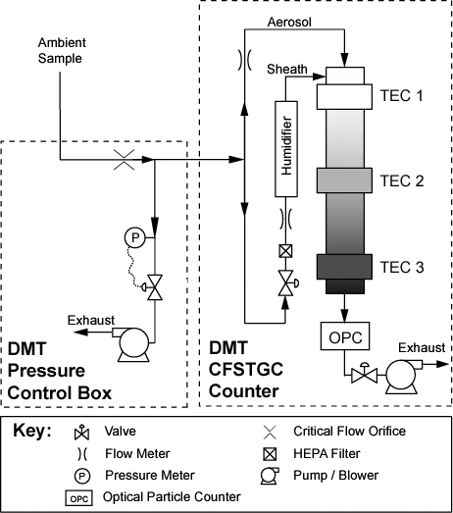

Figure 1: Instrument setup for measuring CCN spectra during SENEX

References
Lance, S., Medina, J., Smith, J.N., Nenes, A. (2006) Mapping the Operation of the DMT Continuous Flow CCN Counter, Aeros.Sci.Tech., 40, 242-254
Moore, R.H. and Nenes, A. (2009) Scanning Flow CCN Analysis - A Method for Fast Measurements of CCN Spectra, Aer.Sci.Tech., 43, 1192-1207
Moore, R.H., Cerully, K., Bahreini, R., Brock, C.A., Middlebrook, A.M., and Nenes, A. (2012) Hygroscopicity and Composition of California CCN During Summer 2010, J.Geoph.Res., 117, D00V12, doi:10.1029/2011JD017352
Raatikainen, T., Moore, R. H., Lathem, T. L. and A. Nenes (2012) A coupled observation–modeling approach for studying activation kinetics from measurements of CCN activity, Atmos.Chem.Phys., 12, 4227-4243
Roberts, G., and Nenes, A. (2005) A Continuous-Flow Streamwise Thermal-Gradient CCN Chamber for Atmospheric Measurements, Aerosol Science and Technology, 39, 206–221, doi:10.1080/027868290913988

